**North South University**

**Department of Electrical and Computer Engineering**

**CSE 215L: Programming Language II Lab**

**Lab** – **11: Abstract Class & Interface**

**Objective:**

* To understand abstract class
* To understand interface

**Task:**

1. Implement the following classes:

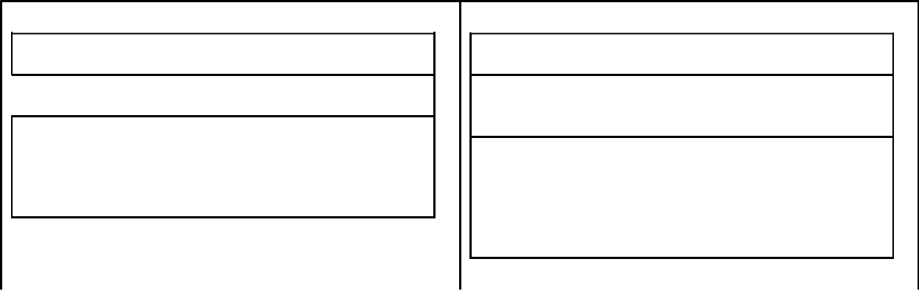

Shape

 - name: String

* Shape(name: String) /* accessor-mutator */
* area(): double
* perimeter(): double

Rectangle extends Shape

* length: double
* width: double
* Rectangle(name: String, length: double, width: double)

/* accessor-mutator */

* area(): double
* perimeter(): double

2. Implement the following classes and invoke discountedPrice() for object of each class.

<<interface>>

Discountable

discountedPrice(price: double): double

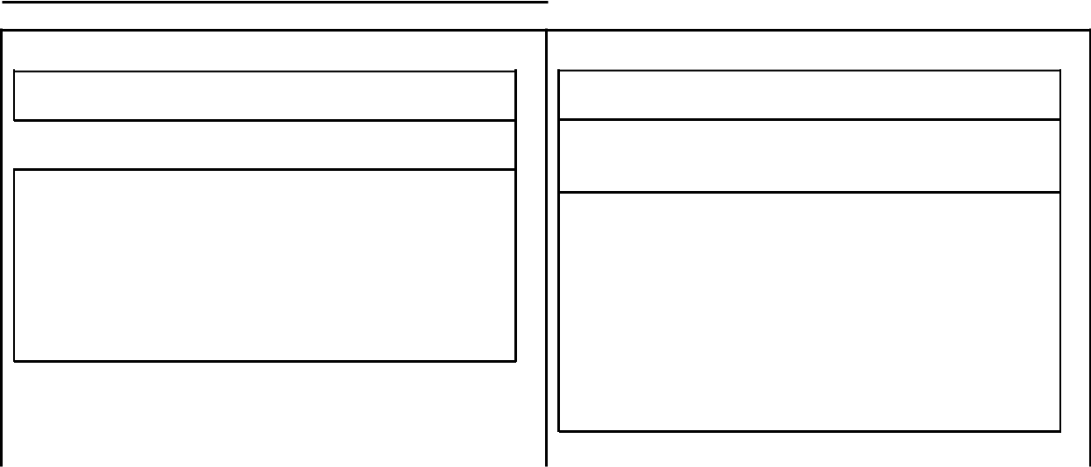

PercentageDiscount  - percentage: double

* PercentageDiscount(percentage:

double)

* getPercentage(): double
* setPercentage(percentage: double): void
* discountedPrice(price: double): double

ThresholdDiscount

* threshold: double
* discount: double
* ThresholdDiscount(threshold: double, discount: double)
* getThreshold(): double
* getDiscount(): double
* setThreshold(threshold: double): void
* setDiscount(discount: double): void
* discountedPrice(price: double): double